Leave
Four
Blank Lines
Before the title
Paper Title in 14-Point, Bold and Left-Aligned
Leave two
Blank lines
First Author¹ and Second Author²
1 blank between names and affiliations
¹Affiliation of first author
²Affiliation of the second author
Leave three
Blank lines
Before the abstract
Abstract The first section of the manuscript should be an abstract, where the aims, scope and conclusions of the papers are shortly outlined. A typical length should be between 100 and 250 words.
Leave one blank line before keywords
Keywords: list 5-6 keywords
Leave one blank lines before first section
Title of First Section
One blank line
Section headings should be in initial caps, 12-points, bold. Leave one blank line between the heading and the first line of the text. At the end of the section, leave two blank lines before the next section heading.

Between paragraphs, leave one blank line gap. The text should be right and left justified. The font should be Times New Roman, 10 points.

Secondary Headings

Secondary headings should be in bold italics, 10-points. Leave one blank line before and after each secondary heading.

Tertiary headings. If they are required, they should be in line with the text. Leave one blank line before tertiary headings. Please, do not use more than three levels of headings, try to keep a simple scheme.

Tables should be numbered with roman numbers (I,II, III, etc.), and illustrations with arabic numbers (1, 2, 3 etc.). Tables and illustrations should be centred, with table or illustration numbers written one blank line after the relevant table or illustration. Leave two blank lines before the table or illustration. Beware that the proceedings will be printed in black and white. Make sure that the interpretation of graphs does not depend on colour.

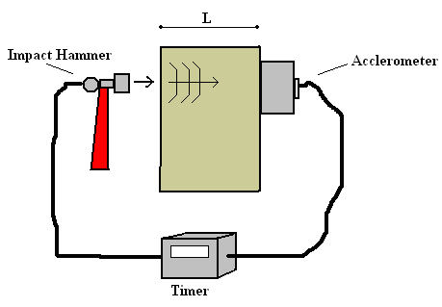
Figure 1. Place the caption below the figure, centered.

Table I. Place the caption above the table, centered.

Material | Configuration | Distance hole to weld centre [mm] | Saw cut
AA2024-T3 | 45º FS weld | 8.3 (for all) | 1-side
AA2024-T3 | 90º FS weld | 0.0; 3.0; 6.5; 6.5 | 2-side
AA7075-T6 | 0º FS weld | 21.6; 16.6 | 1-side
AA7075-T6 | 45º FS weld | 8.3 (for all) | 1-side
AA7075-T6 | 90º FS weld | 7.0; 10.0 | 2-side
AA6013-T4 | 0º FS weld | 19.0; 10.9 | 1-side

The International System of Units (SI) is to be used; other units can be used only after SI indications, and should be added in parenthesis.

Equations should be typed and all symbols should be explained within the manuscript. An equation should be proceeded and followed by one blank line, and should be referred to, in the text, in the form Eqn. (1).
$y=A+\text{Bx}+{\text{Cx}}^{2}$ (1)
Last point: the references. In the text, the references should be a number within square brackets, e.g. [3], or [4–6] or [2, 3]. The references should be listed in numerical order at the end of the paper.

Journal references should include all the surnames of authors and their initials, year of publication in parenthesis, abbreviated title of the journal (in italic), volume number, issue number and pages.

References to books should include all authors surnames and initials, year of publication in parenthesis, the book title (in italic), the name of publisher and place of publication. Reference to multi-author works or proceedings should include, after the date of publication, “In:” followed by the book title, volume number (if any) and pages, name(s) of the editor(s), followed by (Ed.) or (Eds.), name of publisher and place of publication.

Examples:

[1] Author1, A. and Author2, B. (2000), Eng. Fract. Mech., vol. 85, n. 6, p. 1234.
[2] Author3, C. (2001). In: Design for durability in the digital age, Proceedings of the 21st ICAF Symposium, vol. I, pp. 124–138, Rouchon, J. (Ed.), Cépaduès Editions, Toulouse.

Riveted thin-walled structures has been successfully used for many years in the aircraft industry. Riveted thin-walled structures has been successfully used for many years in the aircraft industry. Riveted thin-walled structures has been successfully used for many years in the aircraft industry.

Paper page limit: 10 pages
Margins: Use margins as set in this document.

This is the very last row of this page. This is the very last row of this page.

